### Saudi Tourism Authority

Saudi Rewards - FAQs

Round 4

November 2023

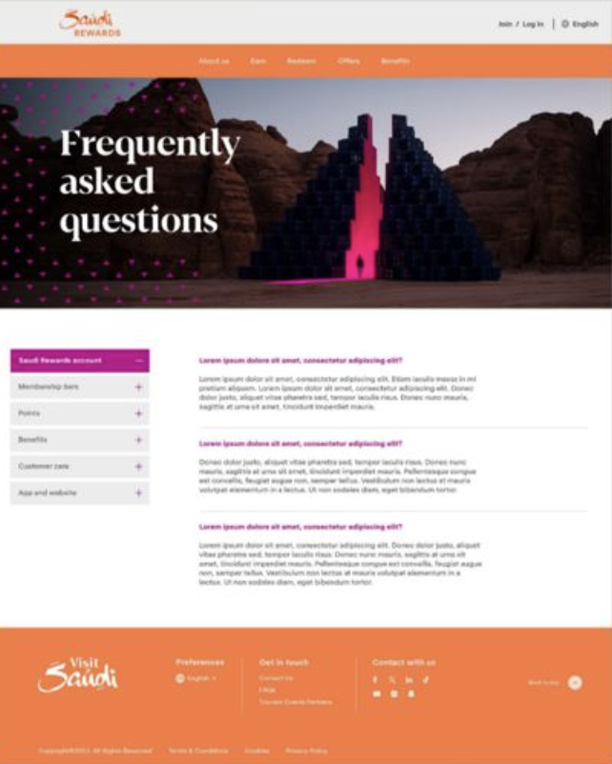

[H1] Frequently Asked Questions

[H2] General Queries

|  |  |  |
| --- | --- | --- |
| General Queries | What is Saudi Rewards? | Saudi Rewards is Saudi’s newest, completely free, first-of-its-kind national rewards program. You can earn and redeem points on tourism events and curated travel deals through our partners, get exclusive unmatched experiences, and offers such as discounts on shopping, dining, excursions and entertainment. |
| General Queries | How does Saudi Rewards define tourism events, travel purchases and lifestyle purchases? | A tourism event is an event or initiative done by one of our participating tourism entities and/or partners. Travel purchases include journeys and accommodations, while lifestyle purchases include everyday activities, such as shopping and dining. |
| General Queries | What are the benefits of joining Saudi Rewards? | There are many ways to enjoy Saudi Rewards! It saves you money, inspires you to seek new experiences and rewards you for purchases you would make anyway. Earn and redeem points when you spend on eligible Saudi events, Saudi City Passes and curated experiences and/or excursions. You’ll get exclusive benefits and offers from travel and lifestyle partners as well! |
| General Queries | How can I check my points balance? | Your available points balance is viewable at any time, right on your My Account page. Just make sure you’re logged in! Your balance is also available on your Saudi Rewards Membership Digital Card! |

[H2] Account

|  |  |  |
| --- | --- | --- |
| Account | How can I update my personal information and interests? | Your Saudi Rewards membership grows with you. As your interests change, or as your personal information needs updating, it’s easy to update your profile, too. Make sure you’re logged in and go to the My Account page to refresh your personal info and interests in just a few clicks. |
| Account | What is my Saudi Rewards Membership ID number? | You’ll be identified by a unique 10-digit Saudi Rewards Membership ID number. To access yours, log in and view your My Account page. |
| Membership Digital Card | How to download my Digital Card? | Please be sure to check the Welcome Email that you received after registering for Saudi Rewards and follow the link in the email. |
| Account | How can I reset my password? | Resetting your password is easy! Just click on “Forgot Password,” and you will receive an email with further instructions. |
| Account | How can I change the language on the Saudi Rewards website? | Hello! Salaam! However you say hello, the Saudi Rewards website can greet you right back. Use the language drop-down menu to select your preferred language. |
| Account | Can I merge two Saudi Rewards accounts? | Sorry, but merging two Saudi Rewards accounts is not possible. There can be only one account per mobile number and email address. |
| Account | How can I close my Saudi Rewards account? | Don’t go! You’ll miss all the rewarding experiences and valuable benefits and offers. If you still want to close your Saudi Rewards account, contact the Call Center, and an agent can help you with deactivation. Call 930 in Saudi or +966 9200 00890 internationally, or email [ask@visitsaudi.com](mailto:ask@visitsaudi.com). |
| Account | What will happen to my outstanding points if I deactivate my Saudi Rewards account? | You’ve got to stay in it to win it. Once you deactivate your account, your points cannot be used; any active offline or partner vouchers will still be valid but may differ from offer to offer. So, if you plan to deactivate, consider using your points online first. And as always, make sure to check the rules and restrictions of each voucher or partner offer. |
| Account | What will happen to my voucher if I deactivate my account? | Unlike points, you can still use vouchers even after you’ve deactivated your account. But make sure you have a copy of the voucher saved somewhere safe — you will not be able to access it with an inactive account. |
| Account | Why do I need to set up a PIN? | A PIN is mandatory to help keep your member information secure, to confirm redemptions with partners and linking of your Saudi Rewards accounts on partner websites. Don’t worry about having one for registration, but it is required once a member signs up and visits his or her My Account page for the first time. You can also access a link in the Welcome Email received upon registration to update your PIN. |
| Account | How do I set up a PIN? | A PIN can be yours in a few simple steps:  (1) Log in to your account.  (2) Click on your My Account page.  (3) Click “Set PIN.” Enter a four-digit number of your choice and confirm it. |
| Account | How do I use my PIN? | A PIN is required by select Saudi Rewards partners to help verify your identity. When completing a transaction with one of those partners, enter your four-digit PIN. This is required to complete the redemption. |

[H2] Enrollment

|  |  |  |
| --- | --- | --- |
| Enrollment | How do I join Saudi Rewards? | We thought you’d never ask! We’re happy to welcome new Saudi Rewards members. Visit the homepage and follow the steps to sign up. |
| Enrollment | Can I only register with a Saudi mobile number? | No! All mobile numbers are welcome. Register with a Saudi mobile number or an international number. |

[H2] Earn Points

|  |  |  |
| --- | --- | --- |
| Earn Points | When do I start earning points? | Points are closer than you think. As soon as you’re registered with Saudi Rewards, you can start earning points when you spend on eligible tourism events or purchase of Saudi City Passes. |
| Earn Points | How can I earn points? | Simple! You can earn points from spending on eligible tourism events. Get more details from the Rewards section on the Saudi Rewards website. |
| Earn Points | How long does it take for my account to reflect my new points? | Every Saudi Rewards partner is different. The time it takes for the points you’ve earned to show up in your account will vary depending on the partner and transaction type. Some partners may take up to 30 days. If you have any concerns, contact the Call Center and share your mobile number and transaction details with an agent so they can advise you on the rules and timeline of your specific transaction. Call 930 in Saudi or +966 9200 00890 for international callers, or email [ask@visitsaudi.com](mailto:ask@visitsaudi.com). |
| Earn Points | Who are the Saudi Rewards partners? | As a Saudi Rewards member, you’re in good company. View all participating partners and offers on the Rewards page. Who knows — taking a look at your options might even inspire you to try something new! |
| Earn Points | How long are my points valid? | Points are valid for different amounts of time, depending on your Saudi Rewards tier. To find out more, visit the Membership Tiers page. |
| Earn Points | Can I buy points with cash? | Some things money can’t buy — like points, which are not available for purchase. |
| Earn Points | What is my earned, redeemed and expired points balance? | Your points balance is viewable at any time on your My Account page, and you’ll be emailed a statement monthly. |

[H2] Redeem Points

|  |  |  |
| --- | --- | --- |
| Redeem Points | Who are Saudi Rewards redemption partners? | Saudi Rewards redemption partners are so special, we can’t tell you about them here. But visit the Rewards page, and you can explore them all. |
| Redeem Points | Do you have any other redemption partners? | All redemption partners are listed on the Rewards page. Check it out to explore all of your redemption options. |
| Redeem Points | What if I redeemed my points for a voucher, but now I would like to cancel it? | Unfortunately, claimed vouchers are not refundable and may not be canceled. Be sure to check each redemption offer as usage rules and restrictions may differ depending on the reward. |
| Redeem Points | Can I redeem points at the partner store, or must redemption be done within the Saudi Rewards website? | Points can be redeemed right here on the Saudi Rewards website.Rewards, including Vouchers can be used in stores, online or both. Please check your reward details to determine the right option for you. |
| Redeem Points | Do I need a minimum points balance to be able to redeem? | There are no minimum points balance requirements. But when selecting a reward, please be sure you have enough points available to redeem. |

[H2] Suggestions

|  |  |  |
| --- | --- | --- |
| Suggestions | How can I share suggestions with the Saudi Rewards team? | We’re here, and we’re listening! If you want to tell us how much you’re enjoying Saudi Rewards, or if you have any amazing ideas about what we could do more of — or do better — email [ask@visitsaudi.com](mailto:ask@visitsaudi.com) or call us at 930 in Saudi (+966 9200 00890 for international callers). |

[H2] Membership Tiers

|  |  |  |
| --- | --- | --- |
| Membership Tiers | What are the different tiers in Saudi Rewards? | Saudi Rewards has four tiers: Silver, Gold, Platinum and Black. Want to make it all the way to Black? The more you spend with eligible tourism partners, curated experiences offered by our partners, or Saudi City Passes, the higher status you’ll earn — and the more member benefits you’ll receive! For more information, visit the Membership Tiers page. |
| Membership Tiers | What are the benefits of each tier level? | You’ll love the points benefits of Saudi Rewards at the Silver Membership Tier, and they only get better from there. Visit the Membership Tiers page to learn more about the benefits of being a Silver, Gold, Platinum or Black Member. |
| Membership Tiers | Can my tier level be downgraded? | Gold, Platinum and Black Members can be downgraded, but great news! You will never be downgraded more than one tier status. Further, as long as you keep spending at your tier’s threshold with eligible tourism partners, curated experiences offered by our partners, or Saudi City Passes, you can maintain your tier and benefits. |
| Membership Tiers | What happens to my points if my tier level is downgraded? | If your tier level has been downgraded, don’t worry — your points will remain active until their expiration date. But that doesn’t mean you should stop earning to upgrade your tier again. Tier status is maintained for one year. |

[H2] Other Questions

|  |  |  |
| --- | --- | --- |
| Other Questions | I’m having an issue that isn’t covered in the FAQs. Can you help? | For any questions that we still haven’t answered, or to troubleshoot specific issues, please contact the Call Center by phone at 930 in Saudi or +966 9200 00890 internationally, or email at [ask@visitsaudi.com](mailto:ask@visitsaudi.com). |

[H2] Rewards

|  |  |  |
| --- | --- | --- |
| Rewards | What is the Rewards page? | The Rewards page is your first stop to start exploring your rewards and to see the exclusive offerings and benefits available to you. |
| Rewards | How do I earn points? | Easily earn points when you engage in Saudi Rewards tourism partner activities, such as eligible event bookings, Saudi City Pass purchases and curated travel experiences. |
| Rewards | How do I redeem points? | You can redeem points in more ways than one. Select from a menu of options on your Saudi Rewards account to apply points toward eligible event tickets, curated experiences and Saudi City Passes. |
| Rewards | What are offers? | Enjoy exclusive rewards, extras and promotions from program partners on dining, car rentals, entertainment and so much more. |
| Rewards | What are benefits? | Benefits are exclusively to Saudi Rewards members with access to additional benefits based on your tier status. Benefits include exclusive deals and experiences for eligible events, Saudi City Passes and curated experiences – making your Saudi Rewards adventures like no other. |

SEO

Meta Title: FAQ | Earn & Redeem Rewards | Saudi Rewards

Meta Description: Discover Saudi Rewards, a national rewards program redefining travel. Earn more points and unlock benefits, and find answers to frequently asked questions here.

URL: /en/faq